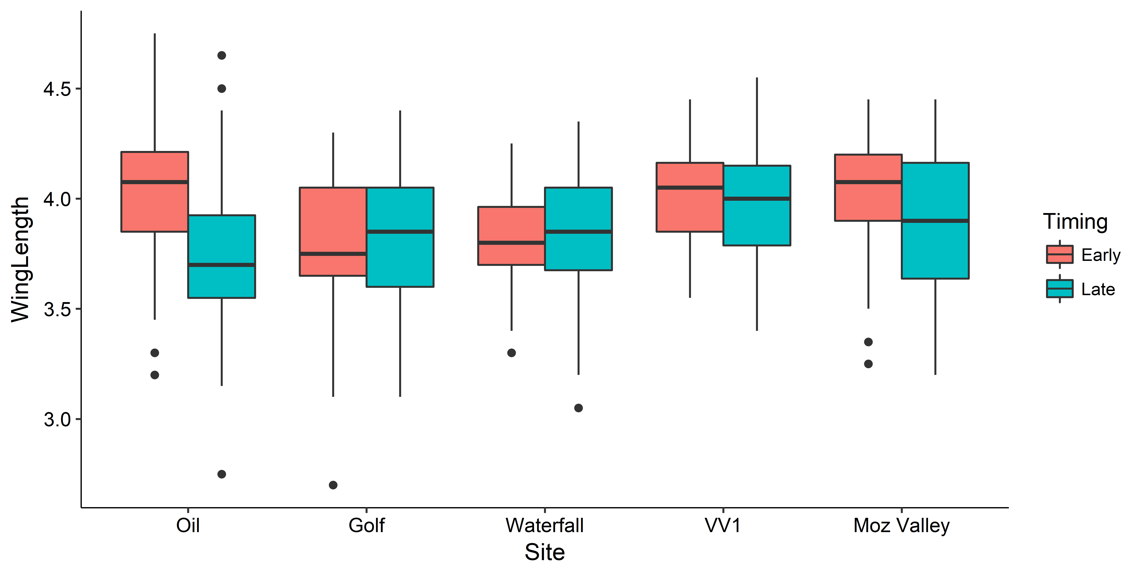

**Site, Timing, and interactions are significant**

Wing length of ~20 mosquitoes from C02 traps from Early vs. late dates and locations

> anova(m3)

Analysis of Variance Table

Response: WingLength

Df Sum Sq Mean Sq F value Pr(>F)

Site 4 1.845 0.46117 4.8868 0.0007597 ***

Timing 1 0.864 0.86358 9.1510 0.0026696 **

Site:Timing 4 0.978 0.24454 2.5913 0.0365150 *

Residuals 350 33.030 0.09437

---

Signif. codes: 0 ‘***’ 0.001 ‘**’ 0.01 ‘*’ 0.05 ‘.’ 0.1 ‘ ’ 1

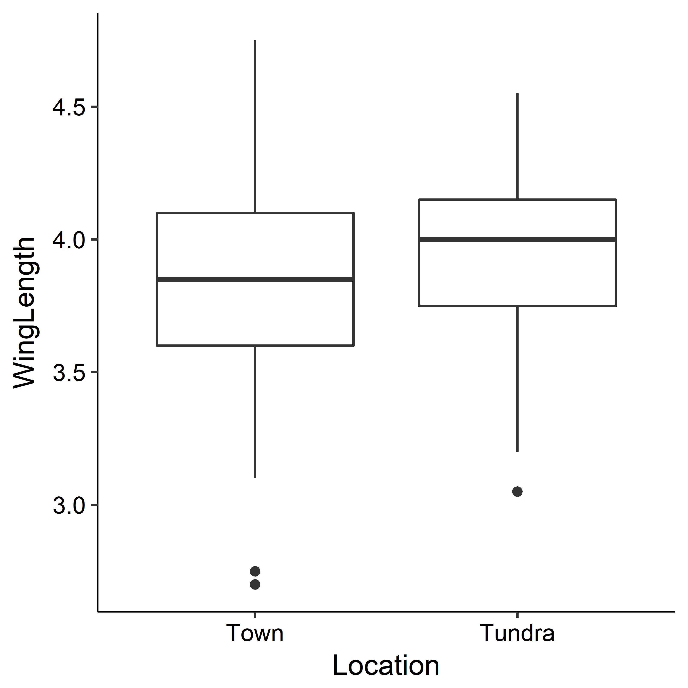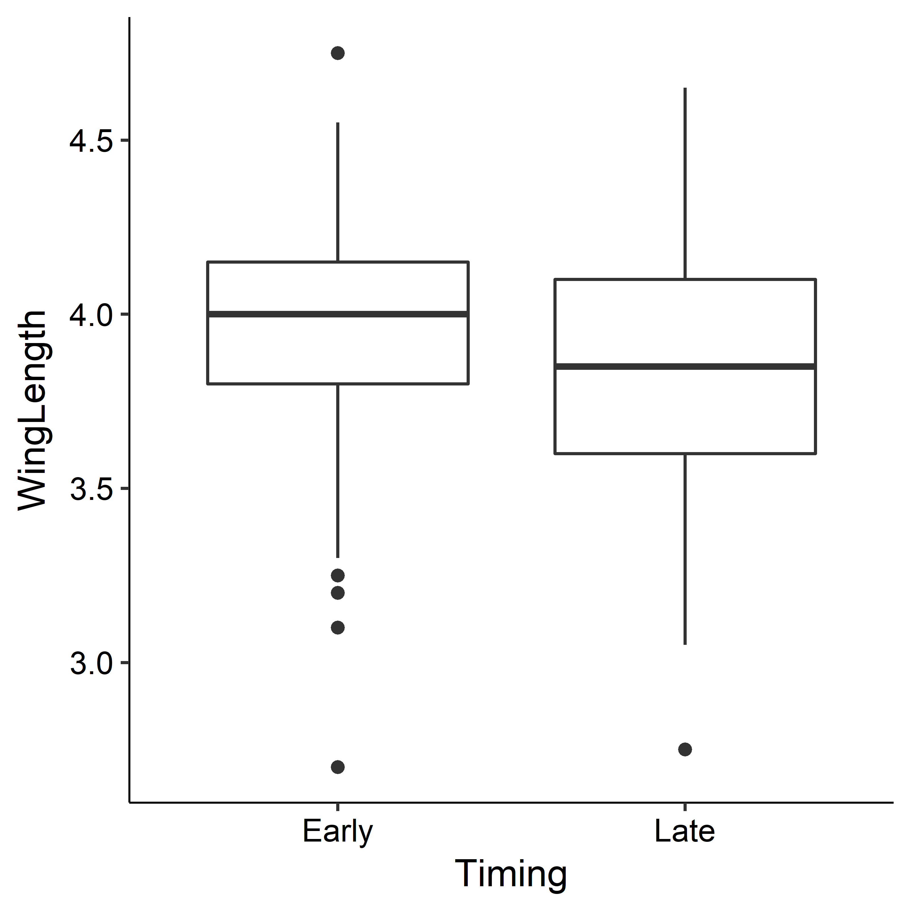

**Tundra mosquitoes are bigger**

> m1<-lm(WingLength~Location, data=C02winglength)

> anova(m1)

Analysis of Variance Table

Response: WingLength

Df Sum Sq Mean Sq F value Pr(>F)

Location 1 0.455 0.45501 4.4923 0.03474 *

Residuals 358 36.261 0.10129

**\][.**

**Early mosquitoes are bigger**

> m2<-lm(WingLength~Timing, data=C02winglength)

> anova(m2)

Analysis of Variance Table

Response: WingLength

Df Sum Sq Mean Sq F value Pr(>F)

Timing 1 0.978 0.97839 9.801 0.001888 **

Residuals 358 35.738 0.09983

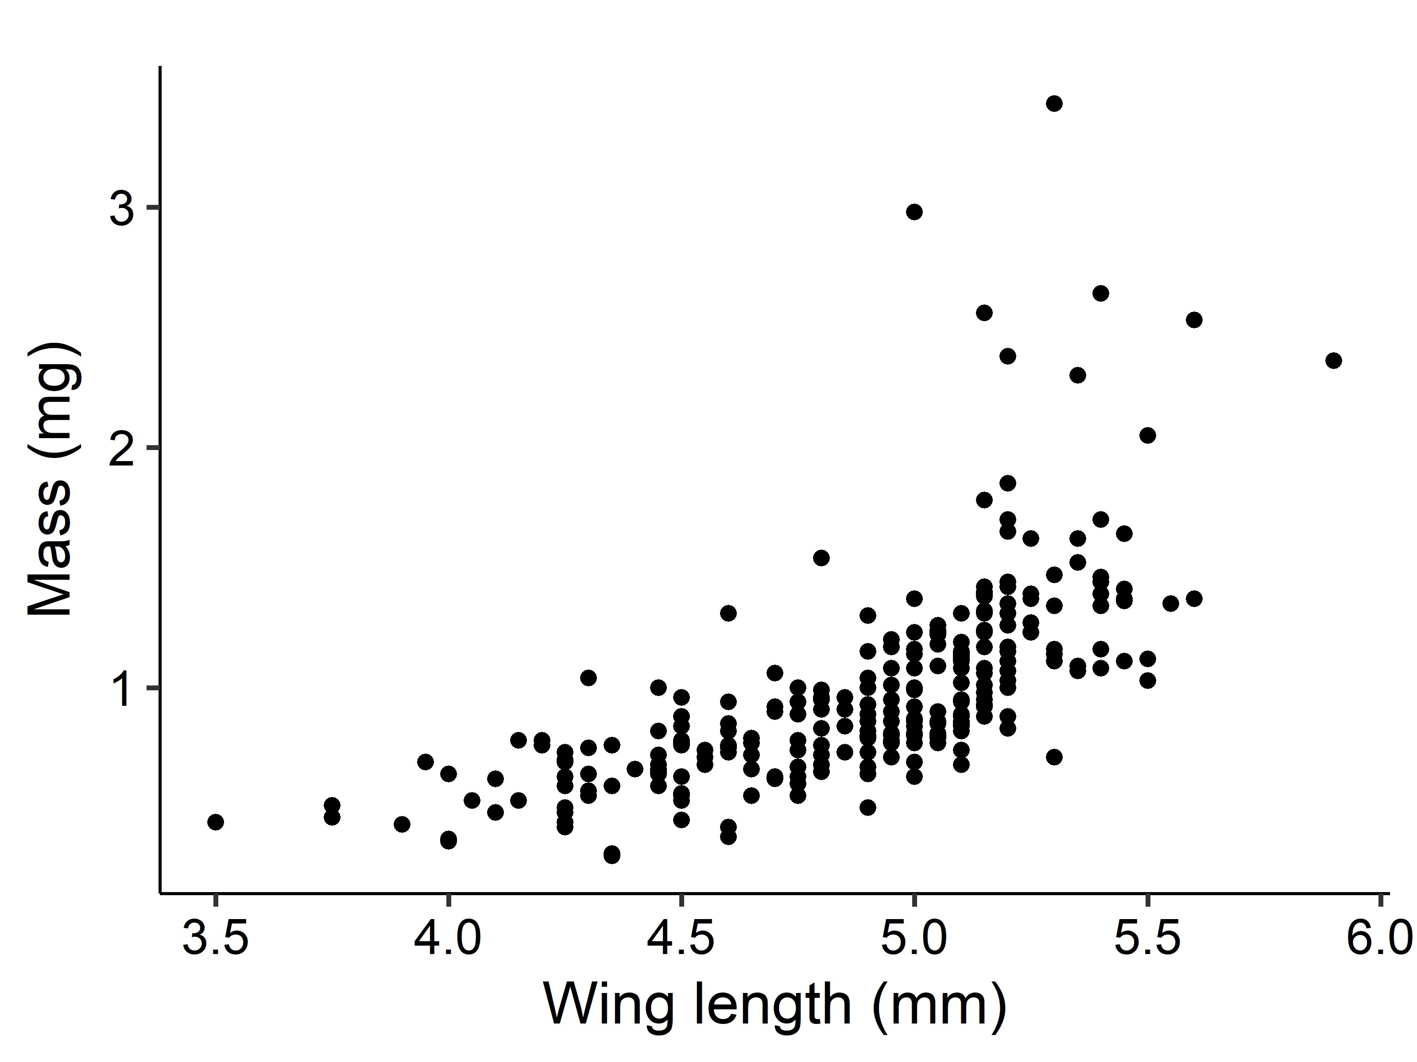

> aictable(rawaic,nR)

Params logL AICc deltaAICc weight cumwt

wingtomasspower 3 -70.2205 146.4893 0.0000 0.9999 0.9999

wingtomasslinear 3 -79.3318 164.7119 18.2226 0.0001 1.0000

> summary(wingtomasspower)

Wing length to mass power function

**Mass = 6.041e-05 X Winglength^4.23**

Formula: AdultMass ~ a * Winglength^b

Parameters:

Estimate Std. Error t value Pr(>|t|)

a 6.041e-05 4.282e-05 1.411 0.159 \]’

b 4.237e+00 3.056e-01 13.864 <2e-16 ***

---

Signif. codes: 0 ‘***’ 0.001 ‘**’ 0.01 ‘*’ 0.05 ‘.’ 0.1 ‘ ’ 1

Residual standard error: 0.3166 on 263 degrees of freedom

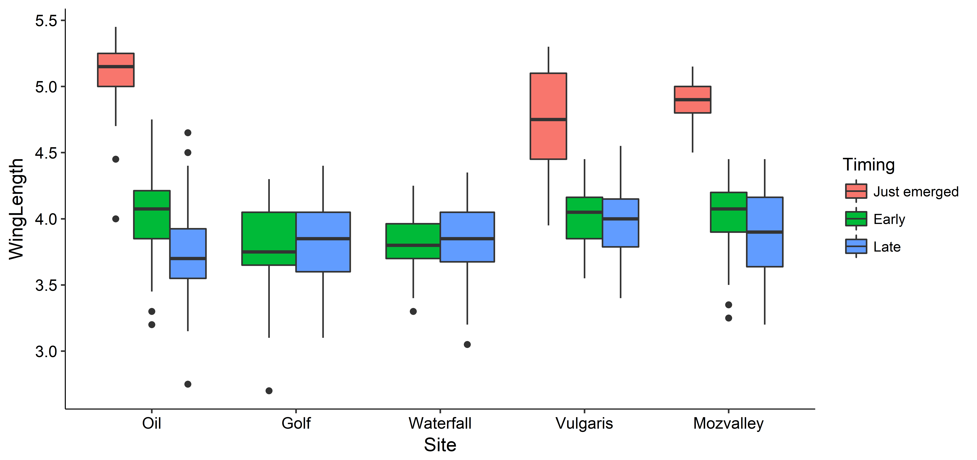

**Just emerged**

**. = from emergence traps**

**Early and late**

**= from c02 traps**

**Moz valley**

Just emerged =6/11

Early = 6/13

Late = 7/12

**Vulgaris**

Just emerged =6/4

Early = 6/8

Late = 7/12

**Oil**

Just emerged = 6/1

Early = 6/2

Late = 7/21